Causal inference : DoWhy

2022년 9월 16일 금요일

오전 10:24

1. Main Microsoft source

* <https://github.com/py-why/dowhy>

: Source codes

* <https://github.com/py-why>
* <https://py-why.github.io/dowhy/v0.8/index.html>

: Getting started, User Guide, and Tutorials

* <https://www.microsoft.com/en-us/research/people/amshar/>

: Main contributor's site

1. Explanations and code examples

* <https://causalinference.gitlab.io/kdd-tutorial/>

: MS' Sharma's good explanation

* [Getting started with DoWhy: A simple example — DoWhy documentation (py-why.github.io)](https://py-why.github.io/dowhy/v0.8/example_notebooks/dowhy_simple_example.html)

* <https://towardsdatascience.com/a-gentle-intro-to-causality-in-a-business-setting-4285aee4b83>

&

<https://towardsdatascience.com/deconfounding-like-a-pro-with-dowhy-c7e03fa03a3f>

: Why causal inference and simple example using DoWhy

* <https://www.kaggle.com/code/adamwurdits/causal-inference-with-dowhy-a-practical-guide>

: Another simple example

1. Causality online course

* <https://www.coursera.org/learn/crash-course-in-causality>

1. Application 1 - Residential energy use in US

* RECS data

: <https://www.eia.gov/consumption/residential/data/2020/index.php?view=microdata>

Machine generated alternative text:
2020 RECS Survey Data 
2020 | 2015 12009 1 2005 | 2001 | 1997 | 1993 | PREVIOUS 
Housing characteristics 
Microdata 
Consumption & expenditures 
Microdata 
Methodology 
State Data 
The 2020 study represents the 15th iteration of the RECS program. First conducted in 1978, the Residential 
Energy Consumption Survey is a national sample survey that collects energy-related data for housing units 
occupied as a primary residence and the households that live in them. Data were collected from nearly 18,500 
households in housing units statistically selected to represent the 123.5 million housing units that are occupied as a 
primary residence. This first version of the 2020 RECS microdata file, released in July 2022, reflects preliminary 
household characteristics data. 
Users are strongly encouraged to read Using the 2020 microdata file to compute estimates and standard errors 
(RSEs). 
Data files 
S SAS csv 
Variable and response codebook 
Survey forms 
ElA-457 A-G 
Release date 
July 2022 

1. Application 2 - Residential energy use in Korea (with 이강희)

* Residential energy panel survey

<http://www.kesis.net/sub/sub_0001.jsp?M_MENU_ID=M_M_001&S_MENU_ID=S_M_008>

Microdata is also available. Need to calculate CDD or HDD based on the location of city. In English website, data from 2018 is available.

Machine generated alternative text:
31 
011 L-d 
7 hfilOll L-d 
12iF(2021 kä 71É) (2023{ 12 
2022-06-03 
11 71É) (2022{ 12 
2021-06-02 
71É) (2021 12 
2021-04-06 
201 91.é (L) 
2022-06-07 
2018 E (L) 
2018-08-07 
2017 Lé (L) 
2018-01-24 
2016 E (L) 
2017-12-06 
2015 E (L) 
2018-04-23 
2014 Lé (L) 
2018-04-23 
2013 E (L) 
2018-04-23 
2012 E (L) 
2018-10-30 
2011 (L) 
2018-10-30 

1. Application 3 - Thermal comfort

* ASHRAE thermal comfort DB

<https://borealisdata.ca/dataset.xhtml?persistentId=doi:10.5683/SP2/GNVEM8>

Machine generated alternative text:
File Type: 
Access: All 
File Tag: All 
Sort 
Download 
1 to 6 of 6 Files 
ashrae db2.01 .csv 
Unknown - 53.3 MB 
Published May 19, 2021 
35 Downloads 
MD5: ff3...652 S 
DI F671 .json 
Plain Text - 8.8 KB 
Published Jul 21 , 2022 
10 Downloads 
MD5: fla...5eO S 
Original JSON from Dryad 
Documentation Code 
db_measurements v2.1.0.csv.gz 
Gzip Archive - 3.1 MB 
Published Jul 21 , 2022 
10 Downloads 
MD5: 75a...b3c S 
db metadata.csv 
Unknown - 220.8 KB 
Published Jul 21 , 2022 
11 Downloads 
MD5: a60...c8c * 
parameter_description.pdf 
Adobe PDF - 87.3 KB 
Published May 19, 2021 
40 Downloads 
MD5: 99d...95a S 
README.htmI 
HTML - 625.7 KB 
Published Jul 21 , 2022 
11 Downloads 
MD5: 9bO...267 S 
-4 

1. Related work

* Energy
* <https://www.sciencedirect.com/science/article/pii/S0306261911000134>
* Machine generated alternative text:
  of 
  House 
  Age of 
  House 
  Size of 
  House 
  Number of 
  Windcysv 
  Of 
  Hmjsehold 
  Size of 
  Household 
  Age of 
  (CDD65) 
  Cmling Erærgy 
  Consumr*ion 
  of 
  AC use 
  Number of 
  AC Roorns 
  Type Of 
  Equiprnent 
  Download : Download full-size image 

* Machine generated alternative text:
  Buildirw 
  Occupant 
  Equipment 
  Download : Download full-size image 
  Energy use 
  Climate 
* Comfort
* <https://www.sciencedirect.com/science/article/pii/S037877881731873X>
* 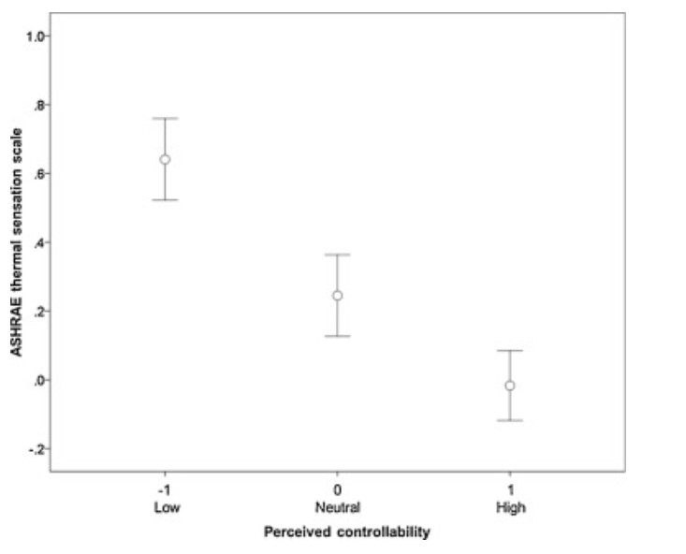
* <https://www.sciencedirect.com/science/article/pii/S036013232100281X>
* Machine generated alternative text:
  Thermal 
  Thermal 
  experience preference 
  Occupant 
  behavioral 
  adaptation 
  bserve 
  variables 
  od 
  arameters 
  weights 
  and biases 

<https://www.ijcai.org/Proceedings/15/Papers/361.pdf>